SQL Project

RETAILERS ORDER MANAGEMENT SYSTEM

NAME: PRANAY GHADGE

COURSE: MASTER IN DATA SCIENCE AND ANALYTICS WITH AI

About Dataset-

Analyzing customer buying behaviour involves examining how consumers make purchasing decisions and interact with products or services. This process begins with collecting data on sales, customer feedback, and website analytics to understand purchasing patterns and preferences. Segmenting customers based on demographics, psychographics, and behaviour helps tailor marketing strategies and identify trends.

Available tables

1.Customer Table

2.Orders Tables

3.Order Details Table

4.Products Tables



ER Diagram

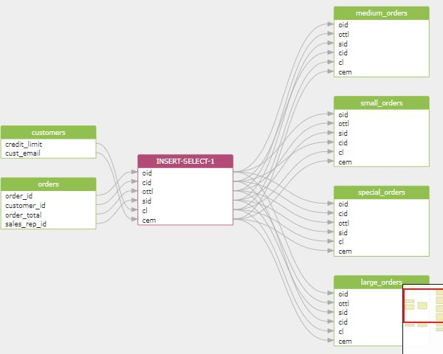

1.display tables ,in order details table

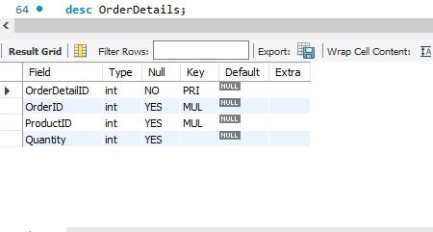

2.Delete and reinsert customer data

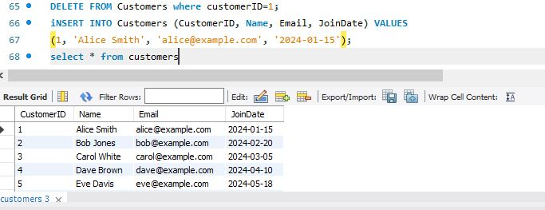

3. Rename order details to order info

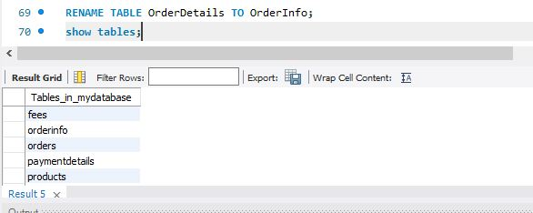

4.display where order id is 1002,1005

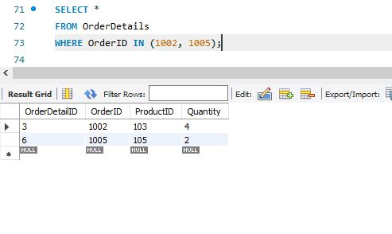

5.update price from 75 rs to 100rs

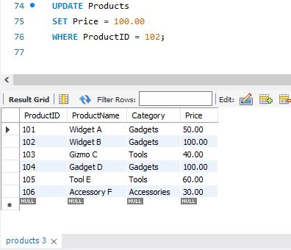

6. Describe orders table

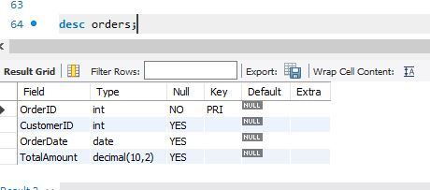

7.Display full name of all customers

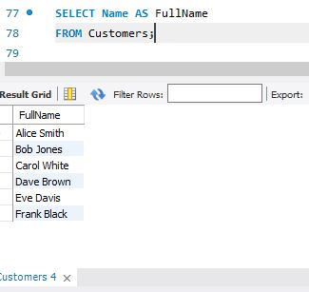

8. Display name of customers but in lower cases

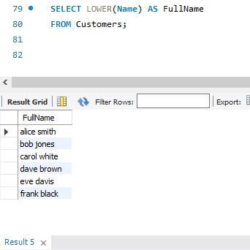

9.Display only product name from product table

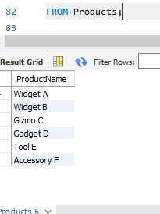

10.Display number of products in product table

.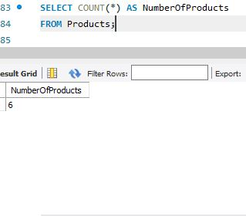

11.Display number of customers whose name ends with ‘s’

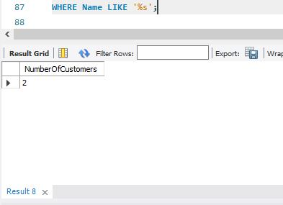

12.Display product categories with price between 100 to 200

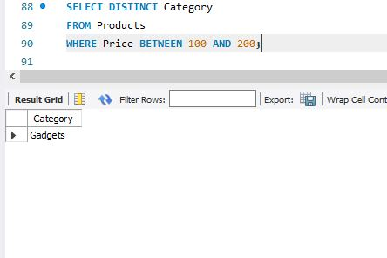

13.Display Customer Name, Order Amount, OrderID, Category, and ProductID

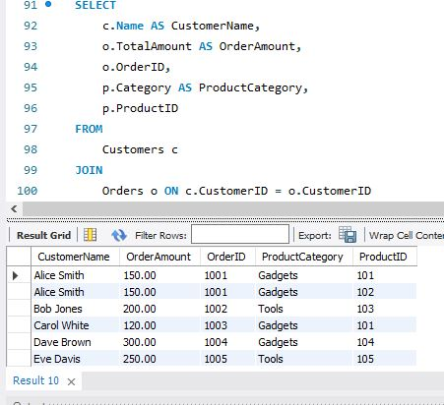

14. Display Consumers Whose Name Ends with 'h' and Order Amount is Less Than 200

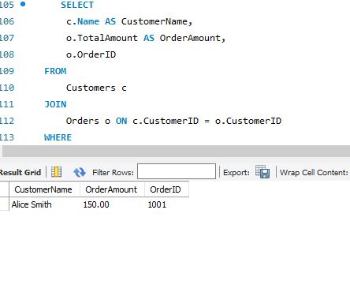

15.Display product id in descending order

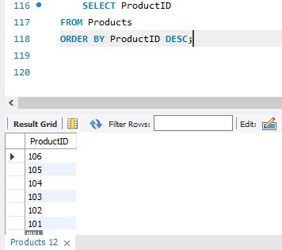

16.Display maximum price for product

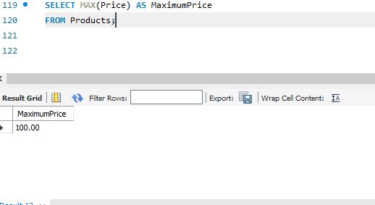

17. Display average price of products

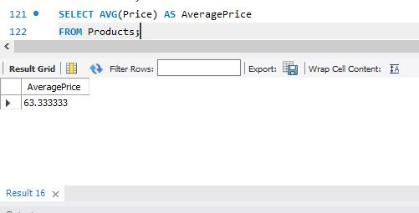

18.Display customer name ,orderID and product amount using nested query

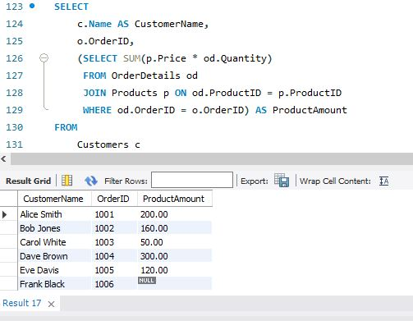

19. Display Customer Name, Product ID, Amount, and Order ID Altogether

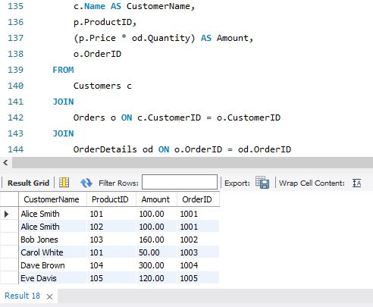

20.Display minimum amount product

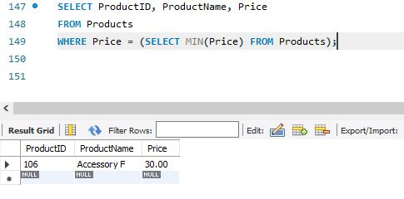

21. Display Date of Order in DD MMM YYYY Format

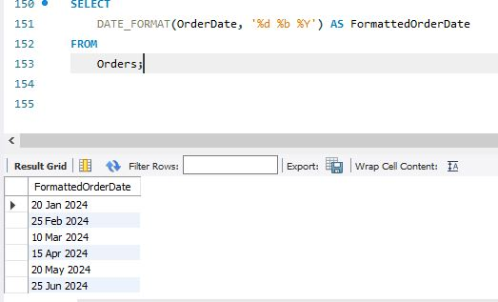

22. Find Length of Product Name

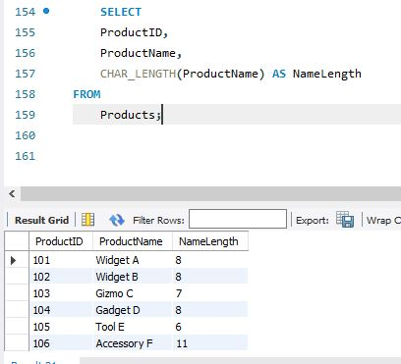

Conclusion: This helps in creating a well-organized and functional database schema suitable for a business that needs to track customers, manage orders, and handle product inventory. The use of primary and foreign keys ensures that relationships between different data entities are clear and enforceable, promoting data integrity and simplifying database operations.